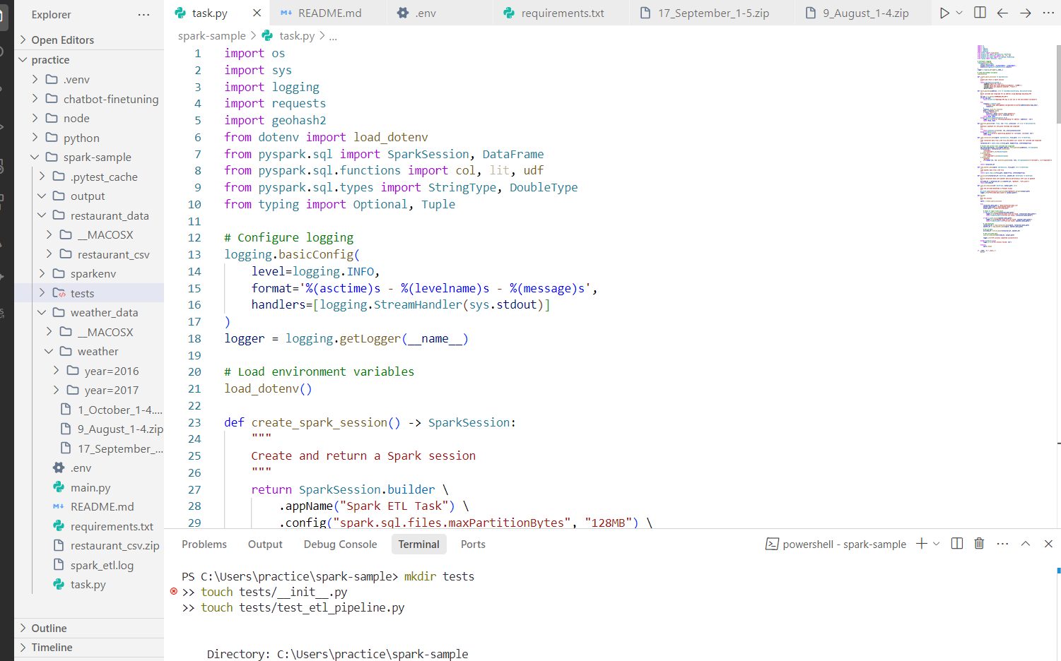 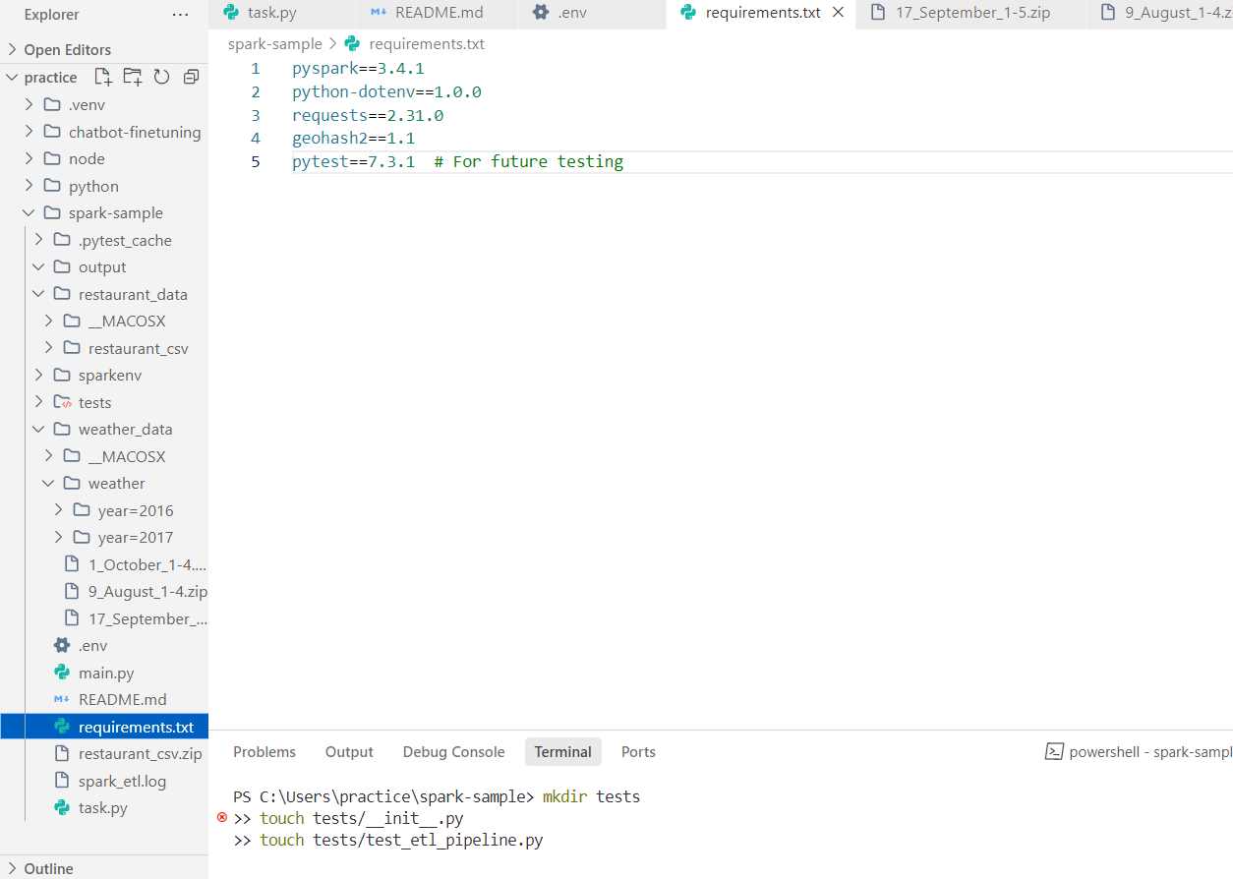 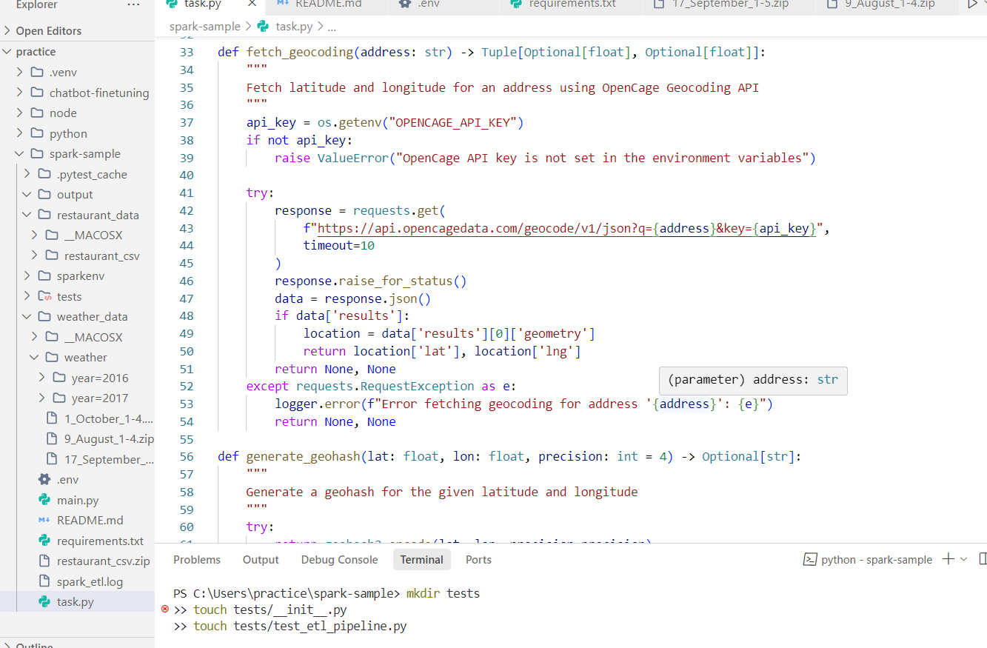 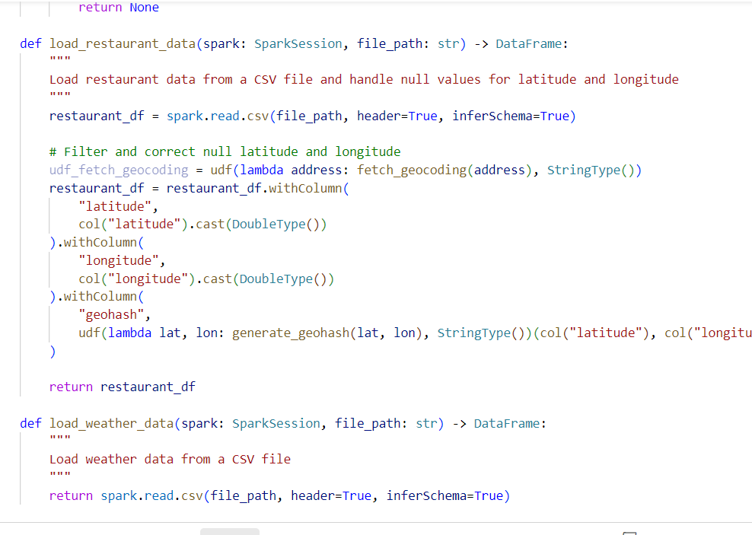

Task.py:

import os

import sys

import logging

import requests

import geohash2

from dotenv import load_dotenv

from pyspark.sql import SparkSession, DataFrame

from pyspark.sql.functions import col, lit, udf

from pyspark.sql.types import StringType, DoubleType

from typing import Optional, Tuple

# Configure logging

logging.basicConfig(

    level=logging.INFO,

    format='%(asctime)s - %(levelname)s - %(message)s',

    handlers=[logging.StreamHandler(sys.stdout)]

)

logger = logging.getLogger(__name__)

# Load environment variables

load_dotenv()

def create_spark_session() -> SparkSession:

    """

    Create and return a Spark session

    """

    return SparkSession.builder \

        .appName("Spark ETL Task") \

        .config("spark.sql.files.maxPartitionBytes", "128MB") \

        .config("spark.sql.adaptive.enabled", "true") \

        .getOrCreate()

def fetch_geocoding(address: str) -> Tuple[Optional[float], Optional[float]]:

    """

    Fetch latitude and longitude for an address using OpenCage Geocoding API

    """

    api_key = os.getenv("OPENCAGE_API_KEY")

    if not api_key:

        raise ValueError("OpenCage API key is not set in the environment variables")

    try:

        response = requests.get(

            f"https://api.opencagedata.com/geocode/v1/json?q={address}&key={api_key}",

            timeout=10

        )

        response.raise_for_status()

        data = response.json()

        if data['results']:

            location = data['results'][0]['geometry']

            return location['lat'], location['lng']

        return None, None

    except requests.RequestException as e:

        logger.error(f"Error fetching geocoding for address '{address}': {e}")

        return None, None

def generate_geohash(lat: float, lon: float, precision: int = 4) -> Optional[str]:

    """

    Generate a geohash for the given latitude and longitude

    """

    try:

        return geohash2.encode(lat, lon, precision=precision)

    except Exception as e:

        logger.error(f"Error generating geohash for lat={lat}, lon={lon}: {e}")

        return None

def load_restaurant_data(spark: SparkSession, file_path: str) -> DataFrame:

    """

    Load restaurant data from a CSV file and handle null values for latitude and longitude

    """

    restaurant_df = spark.read.csv(file_path, header=True, inferSchema=True)

    # Filter and correct null latitude and longitude

    udf_fetch_geocoding = udf(lambda address: fetch_geocoding(address), StringType())

    restaurant_df = restaurant_df.withColumn(

        "latitude",

        col("latitude").cast(DoubleType())

    ).withColumn(

        "longitude",

        col("longitude").cast(DoubleType())

    ).withColumn(

        "geohash",

        udf(lambda lat, lon: generate_geohash(lat, lon), StringType())(col("latitude"), col("longitude"))

    )

    return restaurant_df

def load_weather_data(spark: SparkSession, file_path: str) -> DataFrame:

    """

    Load weather data from a CSV file

    """

    return spark.read.csv(file_path, header=True, inferSchema=True)

def enrich_data(restaurant_df: DataFrame, weather_df: DataFrame) -> DataFrame:

    """

    Enrich restaurant data with weather data by performing a left join on geohash

    """

    enriched_df = restaurant_df.join(weather_df, "geohash", "left_outer")

    return enriched_df

def save_enriched_data(df: DataFrame, output_path: str):

    """

    Save the enriched DataFrame in Parquet format

    """

    df.write.mode("overwrite").partitionBy("geohash").parquet(output_path)

    logger.info(f"Enriched data saved to {output_path}")

def main():

    """

    Main ETL process

    """

    spark = create_spark_session()

    try:

        restaurant_data_path = "data/restaurant_data.csv"

        weather_data_path = "data/weather_data.csv"

        output_path = "output/enriched_data"

        # Check if input files exist

        if not os.path.exists(restaurant_data_path):

            logger.error(f"Restaurant data file not found: {restaurant_data_path}")

            raise FileNotFoundError(f"File not found: {restaurant_data_path}")

        if not os.path.exists(weather_data_path):

            logger.error(f"Weather data file not found: {weather_data_path}")

            raise FileNotFoundError(f"File not found: {weather_data_path}")

        # Load datasets

        restaurant_df = load_restaurant_data(spark, restaurant_data_path)

        weather_df = load_weather_data(spark, weather_data_path)

        # Enrich data

        enriched_df = enrich_data(restaurant_df, weather_df)

        # Save enriched data

        save_enriched_data(enriched_df, output_path)

        logger.info("ETL process completed successfully")

    except Exception as e:

        logger.error(f"ETL process failed: {e}")

    finally:

        spark.stop()

if __name__ == "__main__":

    main()

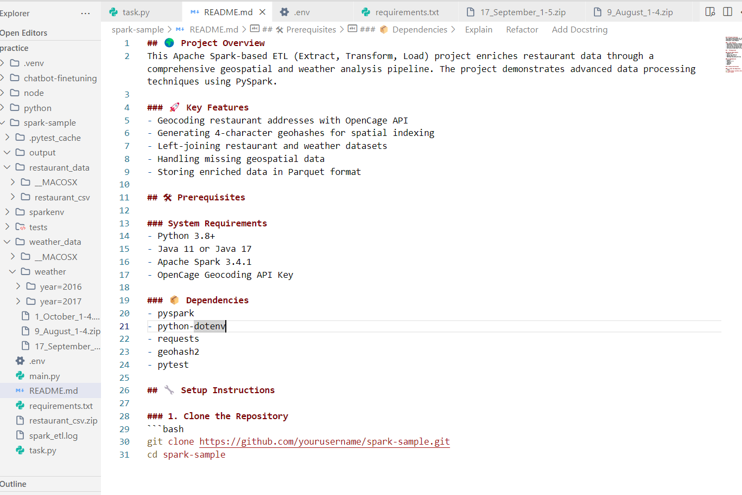

<https://github.com/dilrabonu/Machine-Learning/blob/main/task.py>

<https://github.com/dilrabonu/Machine-Learning/blob/main/README.md>